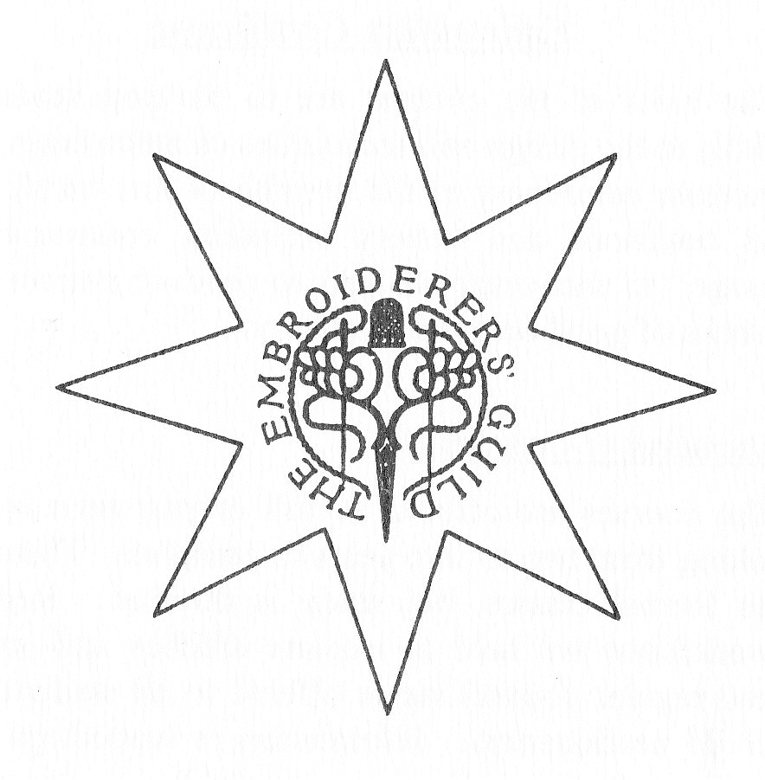

S.A.

The Embroiderers’ Guild of South Australia Inc

CERTIFICATE 1 IN EMBROIDERY

…………......................................………………………………………..

Level 2

……………………………………......................................………………

This booklet is for all students
who have successfully submitted work for the
LEVEL 1 assessment

Student’s Name: ….............……………………………………..
Student No.: ……………………............…………………..
Address: ………..........…………………………………..
……………………..................…………………………………………………..
..............................................................................................

May 2011

Acknowledgements
Many people have assisted with the preparation, development and administration of this Course. The Embroiderers’ Guild of South Australia Incorporated is grateful to all of them. Special thanks go to Meg Douglas who worked as Course Convener and Counsellor since inception of the Course and to the late Jean Lange and also Mignon Ide for their work in designing the Course.

1

CONTENTS

Notes on the Approach to Work for Submission 2 3

Selecting your Work Programme for Submission 2 4

Machine Embroidery and Creative Embroidery 5

Design for Embroidery 6

Core Studies 7

Historical Studies 8

Notes on Assessment 9

Information relevant to all levels in the Level 1 notes as follows:

Study Pathways: page 7

The Embroidery Star: Course Content page 8

Submission Guidelines: page 22

2
NOTES ON THE APPROACH TO WORK FOR SUBMISSION 2

The final works should show PROGRESS from the previous submission.

This may be skills in stitchery, and/or design, showing improvement. It can also be broadening the embroidery experience.

Make an effort to include appropriate core studies to reflect the practical embroidery being done. Most Level 1 and Level 2 aspects of embroidery are based on traditional or historical roots.

Use your samplers not only to explore means for your projects but also to experiment. Try out unusual fabrics and thread. You may prove them to be impractical – this is useful information. Try out colours that you do not habitually include – it might prove exciting. Habits can be stultifying.

Read carefully the comments by the assessors of Submission 1. These comments apply directly to YOUR work alone. While assessors can detect general trends and weaknesses, the remarks on your form are for you to benefit by. If you do not understand what is implied, bring the matter into the open, either at one of the workshops or by private request, where the points will be clarified.

Make the workshops apply to you. Even if you are not working on the counted thread, for example, perhaps the colour, texture, stitch structure, presentation, etc. can be made to suit some aspect of your work.

If, after going through this series of notes and information, you are not sure of your plans for the second Submission, seek guidance. Any member of the management committee will arrange this for you.

Also discuss it with your fellow students. They may have your problem too. The Certificates are in the process of growing. All problems solved now mean an easier passage through the course.

3
SELECTING YOUR WORK PROGRAMME LEVEL 2

The Semi Specialised Course

Two points of the Embroidery Star are continued to Level 2.

Another point is continued to Level 4.

The total amount of work required to complete Level 2 is:

9 Projects (3 Projects from each point) with appropriate preliminary work

18 Samplers (6 Samplers for each point) of techniques not used in the Projects

‘Core’ work which complements the Projects

In all, three points must be completed to Level 2 and one to Level 4.

There is flexibility in the order in which submissions may be made, but this must be discussed at a Guidance Meeting.

The Specialised Course

Two points of the Embroidery Star are completed to Level 4.

The total amount of work required to complete Level 2 is:

6 Projects (3 Projects from each point) with appropriate preliminary work

12 Samplers (6 Samplers for each point) of techniques not used in the projects

‘Core’ work which complements the Projects

4
MACHINE EMBROIDERY

There is NO implication in the Course structure that works must be done exclusively by hand. The machine needle directed by a skilled operator is just as valid.

Where appropriate machine embroidery may be used for any of the techniques listed in the Points and machine techniques may be substituted for hand techniques at will. However, bear in mind that machine embroidery requires particular skills that do not relate to hand embroidery and these should be mastered. Do not use machine embroidery as an excuse to avoid hand techniques.

Little, if any exploration has been done to successfully marry machine work with additional hand work and experimental samplers in this area would be of a personal nature.

Machine work is suited particularly to the Fabric Layered, Fabric Pieced and Fabric Manipulated Points, and can be used in a limited way in Lace Stitches. However, it has been noted that all Points have the possibility of having machine embroidery included at some stage.

CREATIVE EMBROIDERY

Individual concept work may not easily be categorised, but in broad terms may fit into a Point of the Embroidery Star. This is valid within the aims of the course.

Back-up work should enhance the Design/Colour/Experimental aspects of the Core studies.

The creative approach may be used at any level of the course. As with any form of embroidery, care should be exercised as to how much mixed media and mixed techniques are employed. Written statements of concepts should accompany work.

5
DESIGN FOR EMBROIDERY

Wherever possible, design studies should accompany and directly relate to project work. Design is a broad term and often is misinterpreted to mean only drawing and superior drawing skills. This meaning is narrow, misleading and inaccurate.

Design should encompass all aspects of the planning of an embroidery, and include as many of the following aspects of work as makes sense. Everyone is a designer.

- Selection of fabrics and threads to suit each other and the technique chosen.
- The scale of the work decided on, to suit the technique and the function of the piece of work.
- Consideration of colour and tone is required. Even in white-work tone is established by shadows cast by threads and by any decorative holes made.
- In counted work graphs and charts are applicable. Motifs can be taken from any work chart and altered to suit. For example, knitting chart of Norwegian motifs. Graph paper also comes in a tracing paper.
- In surface stitchery, photocopies of actual objects e.g. leaves and flowers may be used as a design material.
- Photography as a design tool may be included. Even the quick snap at the seaside may give a good colour reference.
- Adaptation is one way of making traditional work more individual. Well known motifs can be rearranged by the designer – enlarged – divided- joined, etc.
- Design development from illustrations not of the worker’s invention. Here the adaptation is one of interpretation, from one medium i.e. illustration, to another – embroidery. Interpretation is NOT slavish copying. An embroidery should not result in something that looks like a painting.
- All forms of pattern making can be used in embroidery. Repetition is the essence of pattern. Borders, all-over repeats, random repetition, whatever suits the purpose.
- Enhancing or suppressing the pattern already printed on fabric by the use of embroidery, is an interesting design exercise.
- Consideration of finishing processes as part of the over all design planning is required i.e. mounting and framing, bag handles, cushion edges, tassels and fringes, suitable linings, etc.
- Many of the preceding considerations are inherent in any piece of work, but the quality and suitability of the embroidery techniques are foremost.

6
CORE STUDIES: a clarification of requirements, presentation and assessment of this component of the Embroidery Course.

ALL of the headings in the Core Studies should be addressed sometime during the course.

SOME of these headings should be addressed at each assessment.

The assessors mark off Core Studies as they find them in each submission – in samplers, projects, workshop studies or as special efforts to deal with them.

YARN, FABRIC and STITCH are always there. DESIGN is required, but COLOUR may need a special study if white-work of any kind dominates. An all white submission is not acceptable.

CONSTRUCTION and FUNCTION may be part of projects, but where all flat objects are submitted, then some small constructions should be done too- e.g. bags or boxes or garments – with or without any embroidery included.

EXPERIMENTATION may be included in samplers and/or projects, but untested or extreme examples are best submitted as trial efforts.

HISTORY and TRADITION may appear as part of a project. They may also be a special study with small embroidery samples and captions rather than the more usual essay form. In all cases, some study of several books or actual embroideries should be evident. A ‘theme’ study can be interesting e.g. borders or birds or flowers. Remember TRADITION applies to domestic linen embroideries as well as to Ethnic and Ceremonial usage.

Much of the Core Study material is included in Course workshops.

A workshop folder can be useful for Core studies as well as broadening general embroidery knowledge.

7
HISTORICAL STUDIES

Another aspect of the core studies is history and tradition.

This aspect of the course can be absolutely fascinating. However, it is very easy to be carried away with the enormity of the subject and allow it to overshadow the actual embroidery activity. The study of the History of Embroidery can be related very closely to the projects done and a short statement of the source of the style, with reference giving the book, magazine, exhibition, museum, etc. is adequate for the course. If however, the interest is greater than that allows, then it would be appropriate to do some samplers as part of the historical study. Copies of the Embroidery Journal in the Guild Library have examples of how this can be approached. Some articles show results from the study of one historical piece, museum studies and samplers done after a visit to an exotic country and so on.

Integrate your studies in embroidery and a real understanding and appreciation will grow.

8
NOTES ON ASSESSMENT

The Point of the Embroidery Star chosen will determine criteria for assessment, to a great extent. However, the general criteria from the Level 1 booklet will still apply.

For Level 2 the assessors will also be looking for – in general terms:

- Stitch tension – evenness of surface.
- Good relationship of thread to fabric.
- Tidiness on the back of the work.
- Appropriate presentation finish for the work. Properly pressed, correctly mounted, adequately stuffed and so on.
- Logical and neatly presented notebooks and folders.
- Accurate references and appropriate bibliography.
- General visual appearance of the work.

The members of the Management Committee will make themselves available for guidance, reviewing both written and embroidered work, as well as all design aspects – on request and by arrangement. If their expertise does not cover your problem then they will find appropriate help for you through the library or other Guild members.

Problems can also be dealt with by correspondence.

Too much worry and struggle does not help your craftsmanship.

Discussion of problems with student colleagues at workshops, meetings, etc. is also a worthwhile exercise.

9

